Research Project Criteria

For your final project you will be required to choose two topics (as outlined below) to research throughout the quarter. You will be given some class time to work but will be required to use time outside of class to complete this project. Your research will be presented as two podcast episodes for our class podcast. One episode will be on materials science and the other will be on electrochemistry. Some podcasts you might want to listen to (to get an idea of how a science podcast can sound): Brains on, Science VS (Gimlet), StarTalk, or Chemistry in its element. You can also find our class podcast and listen to last quarter’s students by searching your podcast app for “chemistry 30 class”.

Tasks:

- Choose Topics
- Complete Project Proposals (attached)
- Start Research: Take point form notes in google doc (as below).
- Start Google docs & share with appletone@spsd.sk.ca
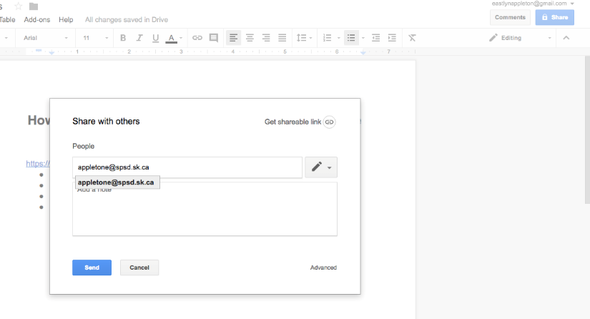

- Start research (may want to wait until project proposal is approved).
- Title your Document: (Your Name)’s Materials Science Research Project and (Your Name)’s Electrochemistry Research Project
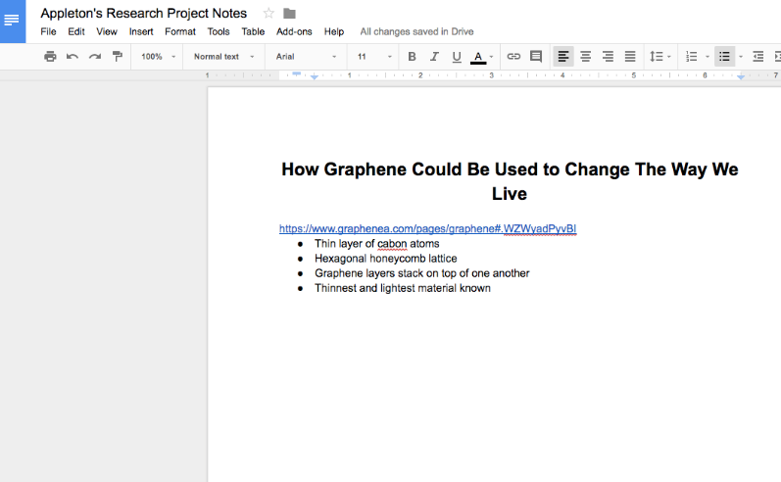
- At the head of document state your topic in bold. Be sure it is clear what you are choosing to research
- Organize you notes as follows:
  - Copy URL Link
  - Write out point form notes of the information you have learned from the website you linked. This is to avoid accidentally plagiarizing.
  - Copy your next link and continue this process.
- Write your Script. Once you have gathered enough information to have a clear understanding of your topic, start writing out your podcast script. Do not delete your notes in order to write the script. Title this document: (Your Name)’s Podcast Script
  - Your Script should be about 750 words, which will become approximately 5 minutes of recording.
  - Include an introduction where you will introduce yourself and the topic you have chosen.
  - Be sure you meet all of the criteria as listed above, as well as all of the criteria listed in the rubric.
  - Write a conclusion that summarizes the key points
- Record your episode and submit the file as an M4A, MP3 or WAV to Mrs. Appleton via email or flash drive. If you do not have recording equipment (an iphone is able to record), you can come in in the morning or at lunch to record.
- Create your show notes, citing all sources using APA format. Your show ntoes shoul be a brief summary of what you discuss in your episode and include links to relevant material the audience may wish to read/view to gain more information on the topic. The show notes should have a catchy title relevant to your topic. This title should start with your name, followed by your unique title. This document will also need to be shared with Mrs. Appleton (appletone@spsd.sk.ca)
- Create one question listeners should be able to answer after they have listened to your podcast episode. Submit the question with acceptable content that should be included with a ‘correct’ answer. The question should require an answer that is a few sentences to a paragraph and show not be something the students can google or answer without listening to your episode. Examples of how your question might start are: “How…”, “Why…”, “Differentiate…”, “Critique…” The questions created by each student will be included in your midterm and final exams.
Project Item | Due Date
Project Proposal for Materials Science Research | Nov 16, 2017
Materials Science Research Google Doc Started | Nov 17, 2017
Research Google Doc Complete | Nov 30, 2017
Script | Dec 6, 2017
Recording | Dec 8, 2017
Show Notes | Dec 11, 2017
Question with Answer | Dec 11, 2017
Completed Questions from other Materials Science Episodes (MIDTERM) | Dec 13, 2017
Project Proposal for Electrochemistry Research | Dec 14, 2017
Electrochemistry Research Google Doc Started | Dec 15, 2017
Electrochemistry Research Google Doc Complete | Jan 8, 2018
Electrochemistry Episode Script | Jan 12, 2018
Electrochemistry Episode Recording | Jan 19, 2018
Electrochemistry Show Notes | Jan 22, 2018
Electrochemistry Question with Answer | Jan 22, 2018
Completed Questions from other Electrochemistry Episodes (FINAL) | Jan 25, 2018
Topic: Materials Science (Midterm Podcast)
Your research project will be focused on materials science, meeting outcome MS4 of the Saskatchewan Chemistry 30 Curriculum. You will choose to either look to the future or look to the past to investigate how advances in materials science influence our world.

Look to the future: Choose a new innovative material and imagine what it could mean for our future.

- Investigate the potential of modern materials (e.g., graphene, aerogels, polymers, nanotechnologies, superconductors, instant adhesives and carbon nanotubes) to change the way we live.
- Suggest a range of suitable applications for a material based on its chemical and physical properties.
- Evaluate the risks and benefits to society and the environment of the material (real or imagined) throughout its life cycle, from raw materials to production, use and disposal.
- Identify criteria (e.g., cost, availability, transportation cost and source of material) used to guide the choice of materials for a specific application.
- Justify the use of the material chosen based on the criteria you have just identified

OR

Look to the past: Choose a product that has evolved over time due to the development of new materials and investigate how new materials have improved the product.

- Analyze how a product (e.g., sporting equipment, clothing, vehicle and building material) has evolved in response to the development of new materials.
- Research the properties of the materials that have helped to influence the evolution.
- Evaluate the risks and benefits to society and the environment of the products (real or imagined) throughout its life cycle, from raw materials to production, use and disposal.
- Identify criteria (e.g., cost, availability, transportation cost and source of material) used to guide the choice of materials for the product.
- Justify the use of the current materials used based on the criteria you have just identified

Each topic will only be able to be chosen by one student, so please ensure you get your project approved by Mrs. Appleton before you begin too much work on it.
Materials Science Podcast Midterm Project Rubric
SDS 1: Create and carry out a plan to investigate one or more topics of interest relevant to chemistry 30 in depth. (5%)
Record Keeping | /10 | Notes for the research project are kept in a google doc shared with Mrs. Appleton (appletone@spsd.sk.ca). The notes are updated regularly and sources are recorded with each set of jot notes. Notes are point form or in your own words so as to avoid any unintentional plagiarism.
Format & Organization | /5 | Has introduction to the speaker and the main idea of the episode. Content follows a logical sequence that is easy for the audience to understand. The main ideas and supporting information is presented in a logical manner. The episode ends with a summary or conclusion that reviews key information.
Sources | /5 | All sources used are cited in the show notes using APA format. Sources include links as necessary, proper capitalization, indentation and alphabetization.
Show Notes | /5 | The show notes contain a one paragraph summary of what was discussed in the podcast episode as well as some further reading or content intended to further the understanding of the topic.
Quality | /5 | The recording is easy to listen to so as to not distract from the content. No unintentional outside noises or sounds can be heard during the recording. Vocabulary used in the recording enhances the content. The speaker maintains focus and speaks in a clear voice, enunciating and speaking at an appropriate volume.
Question | /5 | The question submitted is related to the main topic of the podcast and helps the listener to gain deeper meaning from the content. The question requires some independent thinking as well as recalling information learned from the podcast episode (the question is not something that google can answer).
Your Question’s Answers | /5 | The student also submits an answer to the question, or a list of acceptable items that might be included in a ‘correct/complete’ answer.
Total | /40 | Comments:
MS4: Determine the suitability of materials for use in specific applications. (10%)
Content /25
Content/Criteria | /25 | All questions are thoroughly answered regarding the topic and the audience can gain a clear understanding of the topic from the recording. The quality of the information presented shows a clear understanding by the speaker and is presented in a way that makes the topic easy for the audience to understand.
 |  | - Investigate potential of material to change the way we live.  - Suggest range of applications based on properties.  - Evaluate the risks and benefits to society and the environment  - Identify criteria used to guide the choice for a specific application.  - Justify the use of the material | - Analyze how a product has evolved because of new materials.  - Research properties of materials that influenced the evolution.  - Evaluate the risks and benefits to society and the environment  - Identify criteria used to guide the choice of materials for the product.  - Justify the use of the current materials used
Assignment Answers | /10 | Student has answered 10 marks worth of student created questions. Answers show clearly that the student has listened to the required podcasts and provided some deep thought to their answers. Answers are complete, considering all sides of the problem.
Total | /35 | Comments:

Name:________________________
Project Proposal for Student Directed Study
This will be presented as a podcast which will be published on the internet.
The recording will be due December 8, 2017 and cannot be submitted late.

General Topic: ______________________________________________________________________________
Why I am interested in this topic:
__________________________________________________________________________________________________________________________________________________________________________________________________________________________________________________________________________________________________________________________________________

What do you currently know about the topic? ________________________________________________________________________________________________________________________________________________________________________________________________________________________________________________________________________________________________________________________________________________________________________________________________________________________________________________________________________________________________________________________________________________________

What do you hope to learn about the topic (specifics please): ______________________________________________________________________________ _______________________________________________________________________________________________________________________________________________________________________________________________________________________________________________________________________________________________________________________________________________________________________________________________________________________________________________________________________________
Topic: Electrochemistry (Final Podcast)
Your research project will be focused on electrochemistry, meeting outcome EC2 of the Saskatchewan Chemistry 30 Curriculum. You will choose to either look to the future or look to the past to investigate how advances in materials science influence our world.

Choose one of the following topics to research:
- Investigate the process of corrosion and its prevention (e.g., painting and coating, cathodic protection, alloys, sacrificial anodes and avoiding incompatible metals).
- Investigate the role of oxidation and reduction in biological processes (e.g., photosynthesis, respiration and the action of antioxidants).
- Investigate the role of oxidation and reduction in First Nations and Métis practices (e.g., drying and smoking meat for preservation).
- Investigate how electrical energy is produced in hydrogen fuel cells and various types (e.g., lead‐acid, nickel‐cadmium, alkaline and lithium‐ion) of batteries.
- Investigate the issue of storage of electrical energy as a barrier to large scale adoption of renewable energy resources.

Each topic will only be able to be chosen by one student, so please ensure you get your project approved by Mrs. Appleton before you begin too much work on it.

Criteria:
- Provide a general explanation of your topic
- Provide a chemical explanation of your topic including an example or examples of oxidation- reduction reactions related or involved in your topic (as well as the ½ reactions and the potential energy of the cell)
- Explain the economic impact of these processes
- Explain the environmental impact of these processes

Electrochemistry Podcast Final Project Rubric
SDS 1 (cont.): Create and carry out a plan to investigate one or more topics of interest relevant to chemistry 30 in depth. (5%)
Record Keeping | /10 | Notes for the research project are kept in a google doc shared with Mrs. Appleton (appletone@spsd.sk.ca). The notes are updated regularly and sources are recorded with each set of jot notes. Notes are point form or in your own words so as to avoid any unintentional plagiarism.
Format & Organization | /5 | Has introduction to the speaker and the main idea of the episode. Content follows a logical sequence that is easy for the audience to understand. The main ideas and supporting information is presented in a logical manner. The episode ends with a summary or conclusion that reviews key information.
Sources | /5 | All sources used are cited in the show notes using APA format. Sources include links as necessary, proper capitalization, indentation and alphabetization.
Show Notes | /5 | The show notes contain a one paragraph summary of what was discussed in the podcast episode as well as some further reading or content intended to further the understanding of the topic.
Quality | /5 | The recording is easy to listen to so as to not distract from the content. No unintentional outside noises or sounds can be heard during the recording. Vocabulary used in the recording enhances the content. The speaker maintains focus and speaks in a clear voice, enunciating and speaking at an appropriate volume.
Question | /5 | The question submitted is related to the main topic of the podcast and helps the listener to gain deeper meaning from the content. The question requires some independent thinking as well as recalling information learned from the podcast episode (the question is not something that google can answer).
Your Question’s Answers | /5 | The student also submits an answer to the question, or a list of acceptable items that might be included in a ‘correct/complete’ answer.
Total | /40 | Comments:
EC2: Examine applications of electrochemistry and their impact on society and the environment. (10%)
Content | /20 | All questions are thoroughly answered regarding the topic and the audience can gain a clear understanding of the topic from the recording. The quality of the information presented shows a clear understanding by the speaker and is presented in a way that makes the topic easy for the audience to understand.  - Provide a general explanation of your topic  - Provide a chemical explanation of your topic including an example or examples of oxidation- reduction reactions related or involved in your topic (as well as the ½ reactions and the potential energy of the cell)  - Explain the economic impact of these processes  - Explain the environmental impact of these processes
Assignment Answers | /15 | Student has answered 15 marks worth of student created questions. Answers show clearly that the student has listened to the required podcasts and provided some deep thought to their answers. Answers are complete, considering all sides of the problem.
Total | /35 | Comments:

Name:________________________
Project Proposal for Student Directed Study
This will be presented as a podcast which will be published on the internet.
The recording will be due January 19, 2018 and cannot be submitted late.

General Topic: ______________________________________________________________________________
Why I am interested in this topic:
__________________________________________________________________________________________________________________________________________________________________________________________________________________________________________________________________________________________________________________________________________

What do you currently know about the topic? ________________________________________________________________________________________________________________________________________________________________________________________________________________________________________________________________________________________________________________________________________________________________________________________________________________________________________________________________________________________________________________________________________________________

What do you hope to learn about the topic (specifics please): ______________________________________________________________________________ _______________________________________________________________________________________________________________________________________________________________________________________________________________________________________________________________________________________________________________________________________________________________________________________________________________________________________________________________________________

